Project Documentation

Topic: TANCHIKI

Author: MAXIM KOLESNIKOV

INTRODUCTION

Tanchiki – is a 2D game development on Java FX

* Genre - Arcade
* Platforms - PC
* Game modes - multiplayer (players - 2)
* Target - kill an opponent three times or destroy an eagle of each other
* Number of maps – 6

MOTIVATION

* I wrote this game to relax and get fun with friends during boring weekdays
* This game reminds me about light child where all was so easy and my friends and I after school could play at someone's house in «SEGA»

ARCIHETURAL STRUCTURE OF THE PROJECT

* 9 classes
* 26 images
* 1 css file
* 12 music

UML DIAGRAM

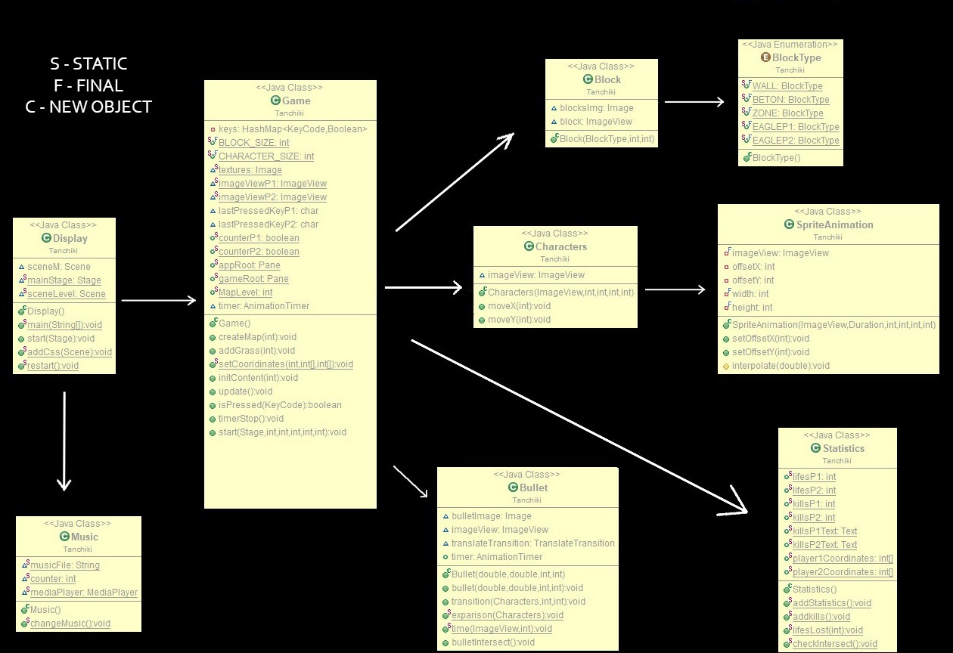

Screenshots: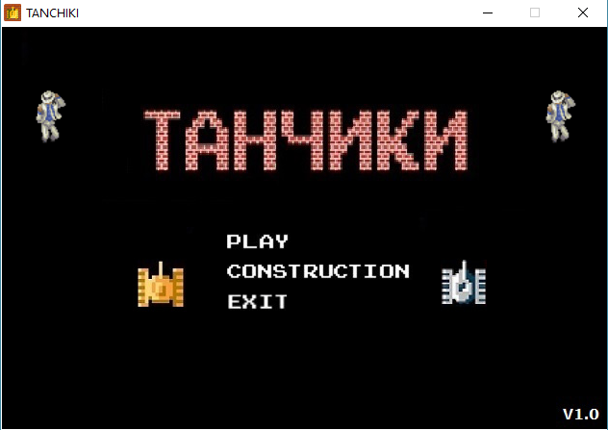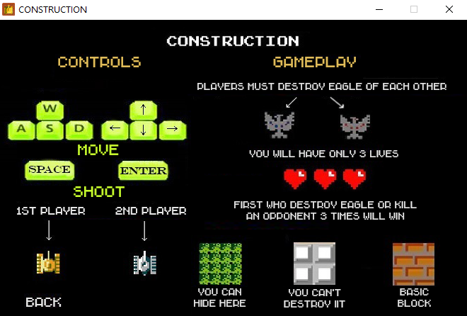

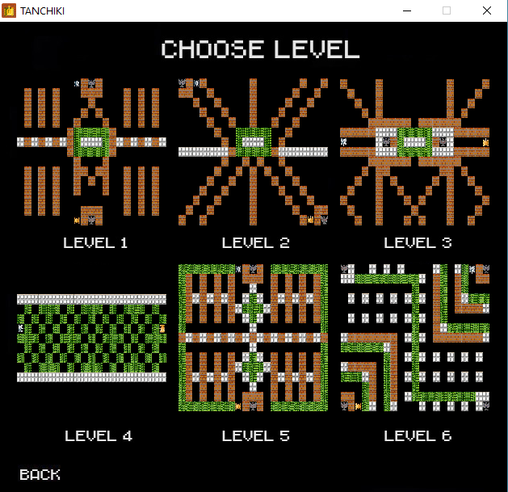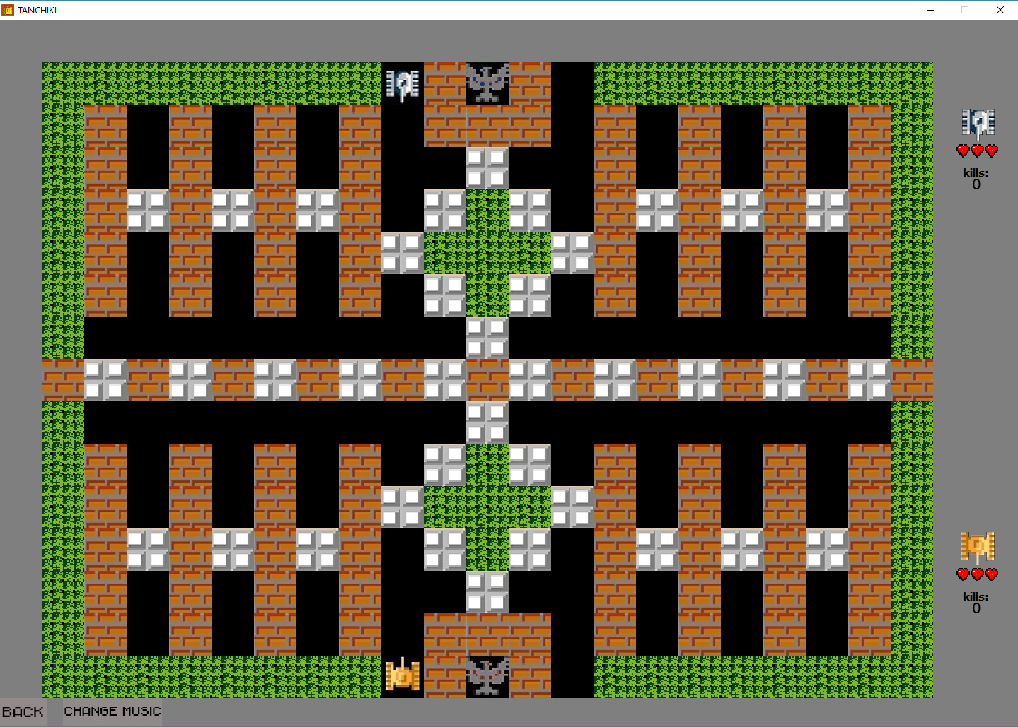

This project works on Java FX

First what I did is create a map(Array of strings)

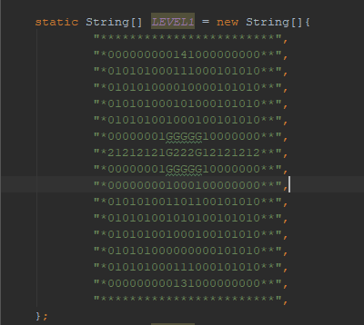

0 1 2 3 4 * is a block

0 – is null block

1 -  2 -  3 -  4 -  G -  * - 

Size : 17 X 24 blocks

Block_Size=60px

Then we call a method which finds a case of letter and create a block : create an object of class Block

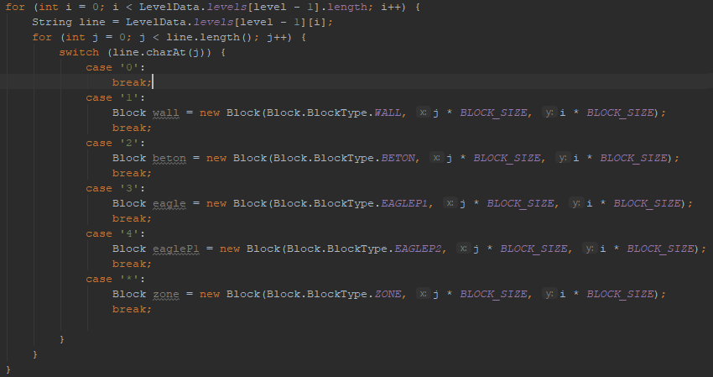

This class adds a block to an ArrayList of blocks(player collision with blocks) and set it to Pane.

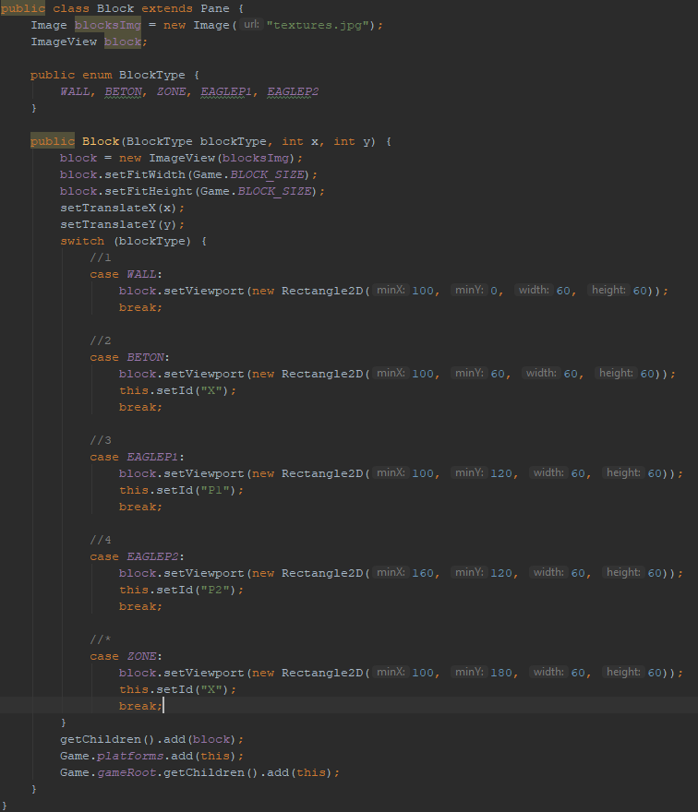

Then I create two players – Object of class Characters

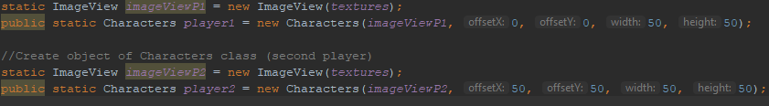

Class Characters have 2 methods - moves players by x and y axis

When a player is moving each bias to 1 pixel , for loop check a collision with blocks(ArrayList)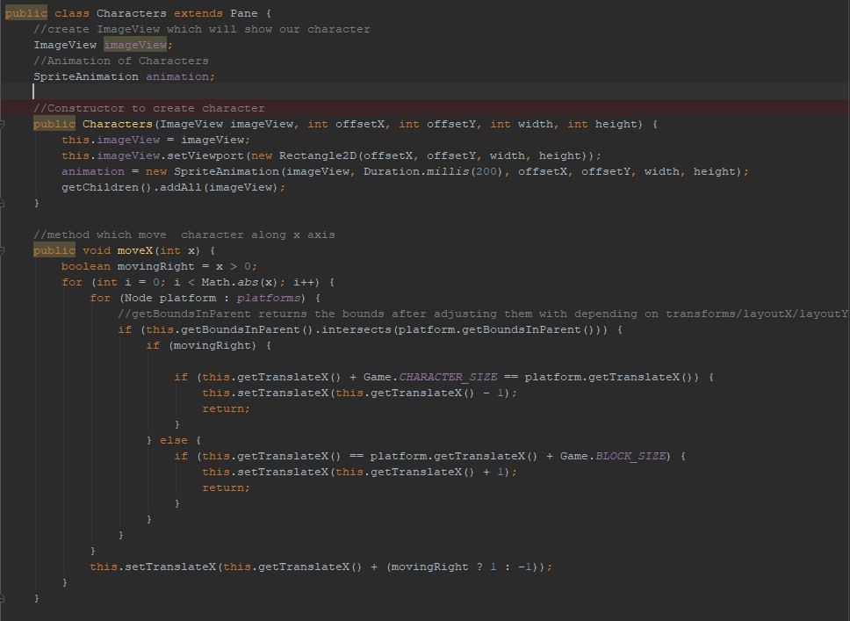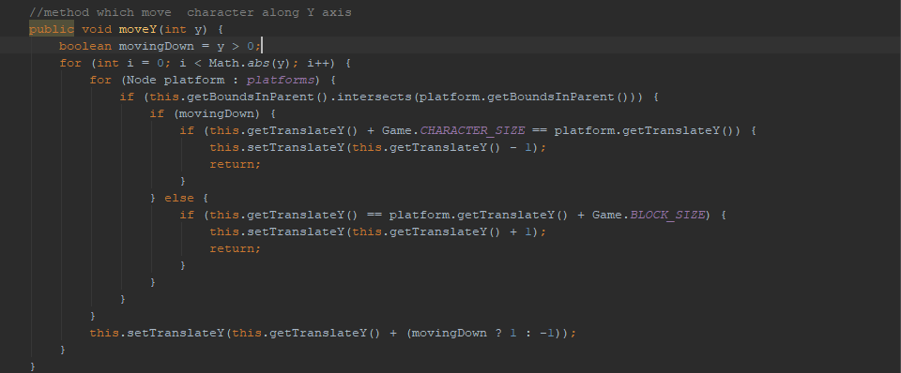

Player moves by Sprite Animation

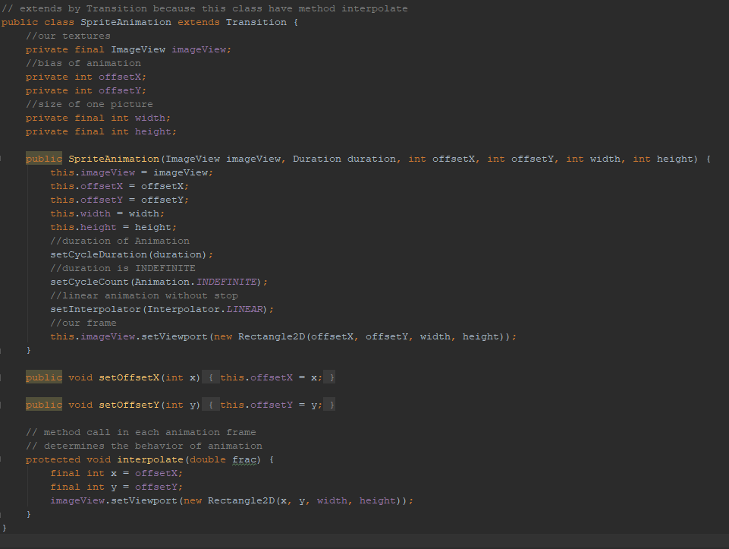

How it works:

A sprite is a single graphic image that is included in a larger scene.

Sprites are a popular way to create large, complex scenes as you can manipulate each sprite separately from the rest of the scene. This allows for greater control over how the scene is rendered, as well as over how the players can interact with the scene.

Example: It’s my texture

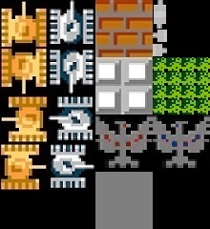

When player1 pressed on W, animation set y on 0 and x on 0 (default) and move player by y on - 2px

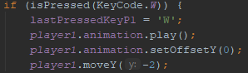

It’s here



When player1 pressed on S, animation set y on 50 and x on 0 (default) and move player by y on 2px

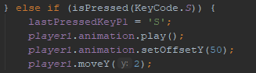

It’s here



When player1 pressed on A, animation set y on 100 and x on 0 (default) and move player by x on -2px

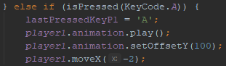

It’s here



When player1 pressed on D, animation set y on 150 and x on 0 (default) and move player by x on 2px

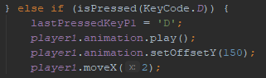

It’s here



After that I added a Grass

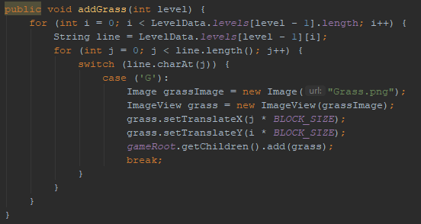

So we got three layers:

3 – Grass

2 – Players

1 – Blocks

Why?

 

I did it so player can walk on broken blocks and hide in Grass

How my project works?

Animation Timer execute in each frame of game and call methods update() which move characters,

checkIntersect which check intercsetion of two player and timerStop() which stop the game if eagle of each other is destroyed or someone died 3 times

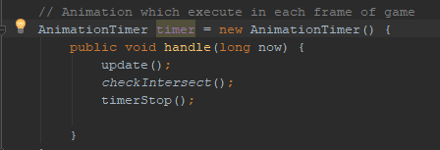

My next step is create a Bullet

lastPressedKey is use to determine an direction of bullett

Create an object of class Bullet

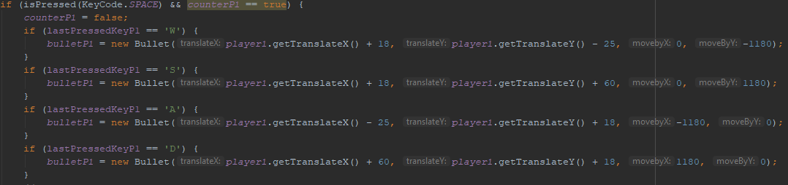

Class bullet create an object of Class Character

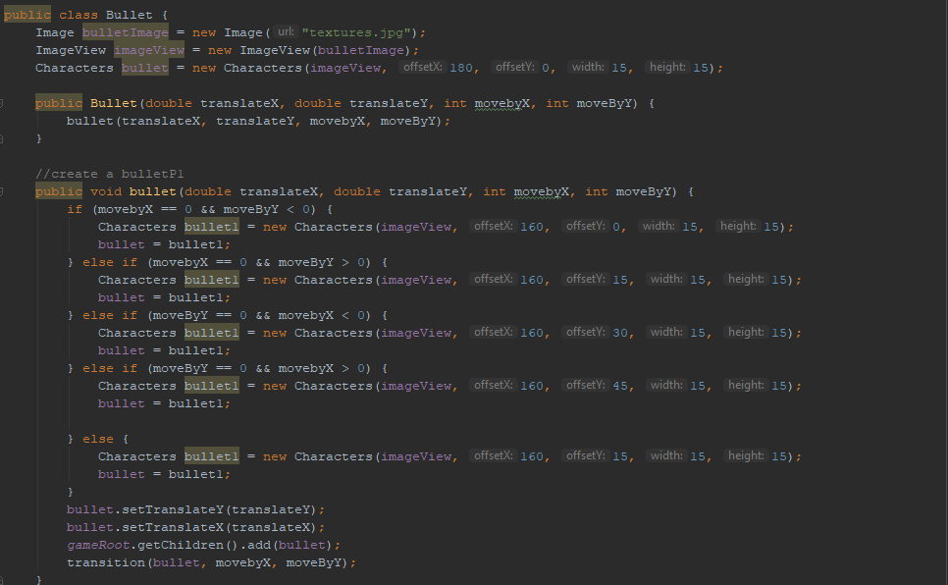

I move my bullet by transition

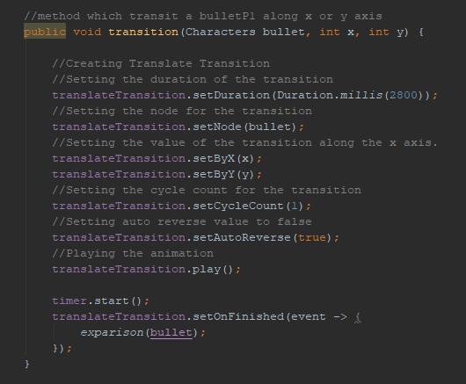

I create a new AnimationTimer and it work until bullet is don’t intercect with something

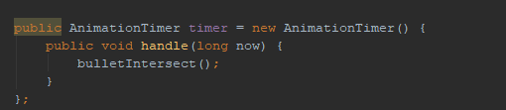

bulletIntersect() – check intersectoin of bullet with player, blocks and eagles

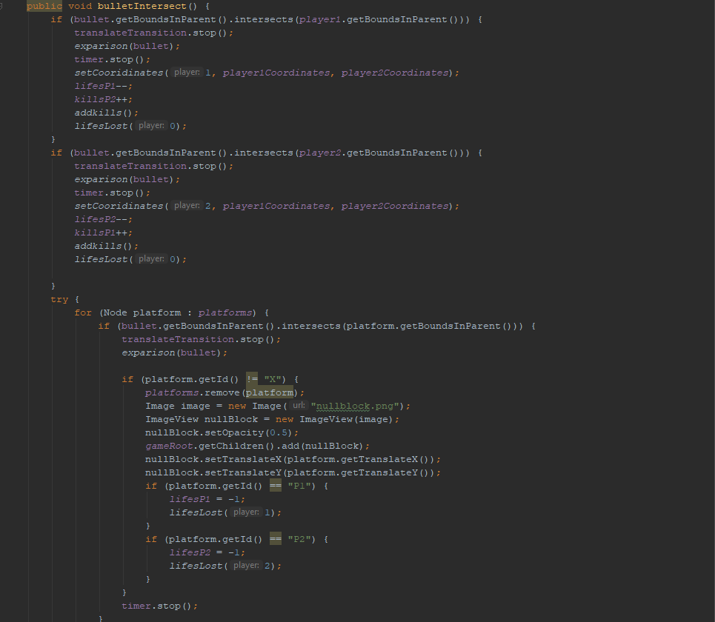

When bullet intersect with something we call method exparision

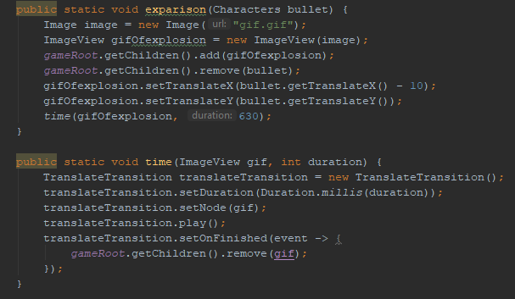

Exparision() create a gif of exparisrion on interesection

References

I used references from this video <https://www.youtube.com/watch?v=lDscImkuFYM&t=1s>

Here author create a game “Mario” and used Sprite Animation. I used references from this video.

Conclusion

* the project was made by Maxim
* duration of development : two sleepless nights
* Be always happy<3
* <https://github.com/macsifan/Tanchiki-JavaFX>